School of Digital Media & Infocomm Technology (DMIT)
ST1011 Applications Development
Practical 0
Installation of Tools for APPD

Objectives:
After completing this lab, you should be able to:
- Install Raptor - a flowchart tool
- Install Visual Studio 2015 Community Edition

- We will using Microsoft Visual Studio 2015 Community Edition as an IDE to develop C# programs. Download the file VSCommunity.2015.zip from Blackboard Learning Resources Topic 1 and unpack the file.

- Install Visual Studio by double clicking the file vs_community.exe.

- During the installation, you should see something similar to this screen, choose Typical, the installation will take about an hour depending on your laptop’s performance.

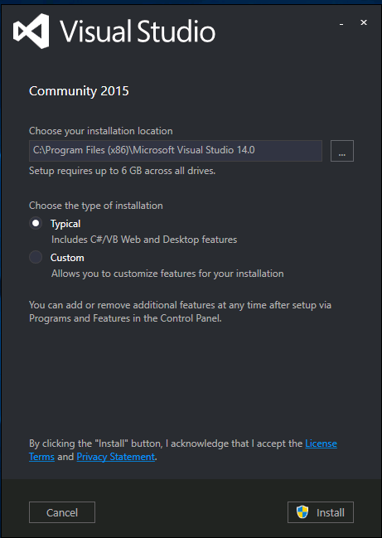

- Launch Visual Studio by clicking on the LAUNCH button.

- Test the IDE by creating a new Visual C# Project:
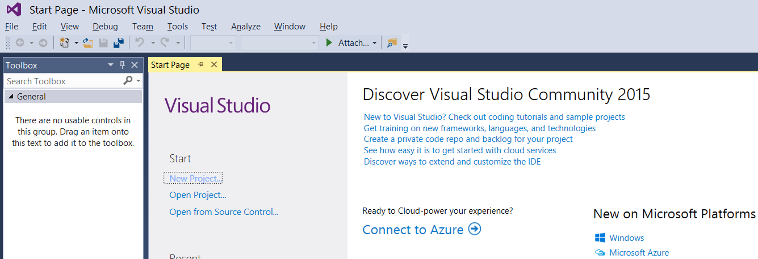

You may choose to select the folder to place your project.
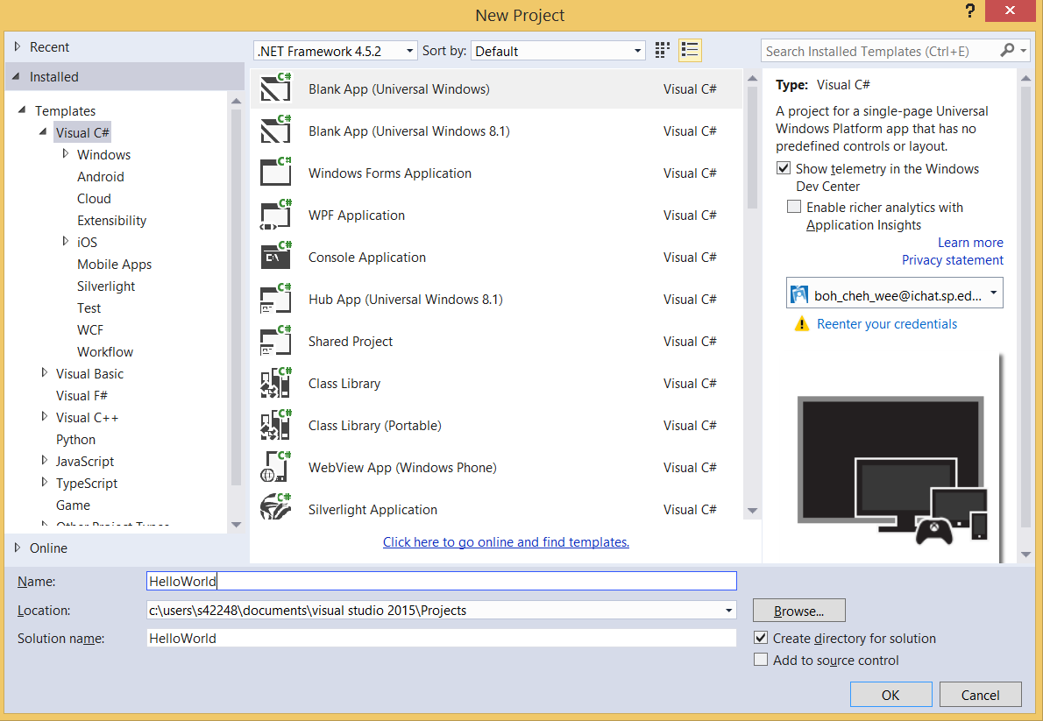

- Type in the following code at line 19:
- using System;
- using System.Collections.Generic;
- using System.Linq;
- using System.Text;
- using System.Threading.Tasks;

- namespace HelloWorld
- {
- class Program
- {
- static void Main(string[] args)
- {
- Console.WriteLine("Welcome to APPD");
- Console.ReadKey();
- }
- }
- }

- Run the project and you will see the following output. Press any key to end the program.

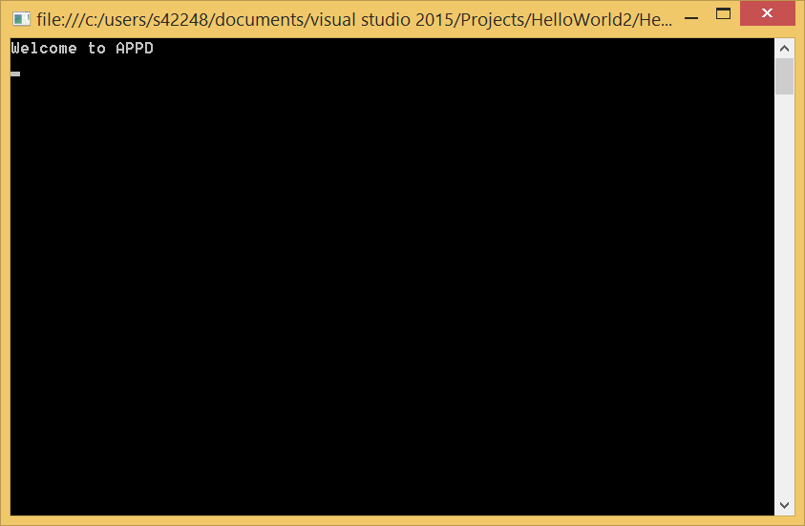

- END -

